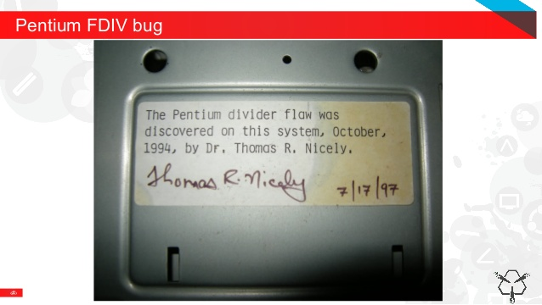**Post 20 software for post 20 uarithmetic.py**

Well, a bug popped up. Sort of.

When reading through the VTL-2 stuff I noticed it uses positive integers only 0-65535. The problem is my arithmetic routines only do -32768..32767. So I sacrificed my in ROM message to have two divisions – forward slash (signed) and backward slash (unsigned). Multiply works for both.

Retesting revealed a bug in going from 15 to 16 bit division, checking the result sign rather than the Carry flag when doing the test subtraction, so I replaced that. It almost doesn’t really count as a bug, because originally values were only going to be 15 bit.

But anyway, that one is fixed.

I’ve added, for no reason at all other than I can, a booting beep to the machine.